|  |
| --- |
| Team 14 |
|  |

# Memorandum

To: IT Director

From: Team 14

Date: October 4, 2023

Subject: Palo Alto DOS

In response to the CEO’s Concerns, we have defined a DoS Protection Policy with zone protection on the EXTERNAL Zone. With in the Dos Protection Profile. we have set up SYN flood and UDP flood Protection.

Image 1: Policy Configuration. 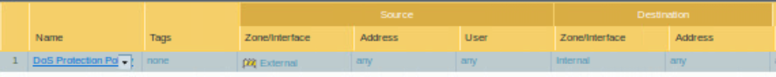

Image 2: Policy Configuration Continued.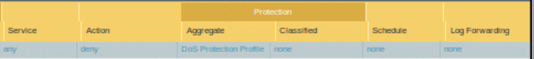

Image 3: DoS Protection Profile.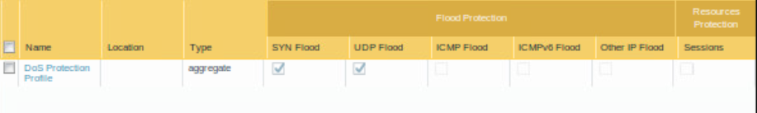

Thank you,

Team 14